|  |  |
| --- | --- |
|  | **MGM's College of Engineering and Technology Kamothe,**  **Navi Mumbai - 410 209** |

Department of Electronics and telecommunication Engineering

**SKEP WEEK 3**

**REPORT**

**DATED- 06/09/2018**

**Time: 4:00 PM**

**Address: MGM's College of Engineering and Technology Kamothe, Navi Mumbai.**

**ABOUT SKEP: - Skill and Knowledge Enhancement Program**

Skill and Knowledge Enhancement Program (SKEP). SKEP organizes talks, tutorials and distinguished lectures with an intention to reach out to students, faculties and industry professionals. SKEP programmes are an exercise in life-long learning and are offered for the continuing education and skill up gradation of professionals. In addition, this program seeks to motivate and inspire the young student community and endow them with a rare insight into what the industry has to offer and its expectations, thus helping them ease their entry into corporate life. Main goals of SKEP include professional skills development, imparting technical expertise to develop viable applications, disseminating useful knowledge from current fields of interest to the beneficiaries and inculcating technical and logical thinking among the student community. SKEP programmes are conducted by invited experts on the state-of-the-art topics from among the research, academic and industrial areas. The intended audience is students, faculty, IEEE members and other interested persons from research, industry and academic institutions.

As part of activity of SKEP, the department of EXTC Engineering organized a guest lecture inviting **Dr. Nitin Kale (PhD) Chief Technology Officer,Nanosniff Technologies Pvt Ltd** on 6th September 2018 at Sir Visvesarya Seminar hall. Students of Second year , Third Year , Final Year EXTC attended the lecture. In his address, **Dr. Nitin Kale**  discussed on the topic “**MEMS Based Sensors For Chemical & Biomedical Sensing Application**”.

**ABOUT The Department :- Electronics and telecommunication Engineering**

**Vision -** To produce world class Technocrats, Scientists & Entrepreneurs with new ideas & innovations to meet cost effective industry expectations for all sections of society.

**Mission –**

1.To develop & deliver quality academic programs in emerging & innovative field of Engineering to empower the students to meet Industry Standards.

2. To motivate students to develop innovative solutions for betterment of society.

3. To Create Centre of Excellence by establishing the Incubation Centers to meet global research challenges.

We Started with Introductory Speech by one of our I.E.E.E member Miss Shareefa Batul & then inviting our Guest  **Dr. Nitin Kale** for the talk.

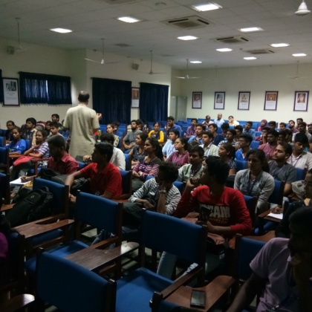 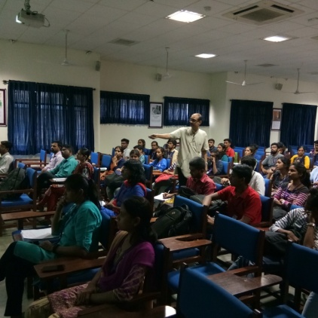

Figure: Glimses of the lecture

In his lecture  **Nitin Kale** discussed the Following :-

* A MEMS device
* MicroCantilevers as MicroSensors
* Instrumentation-Sensimer

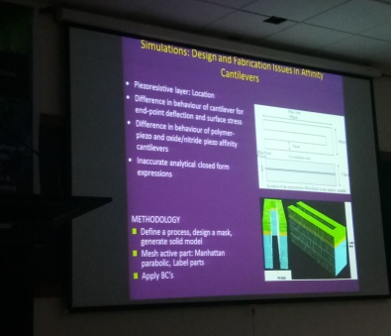 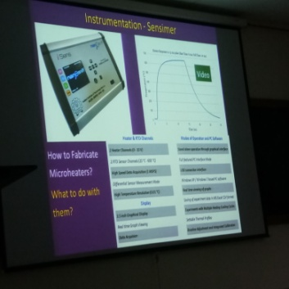

Figure: Fabrication issues in Cantilevers Figure: MicroCantilever as Microsensors

Products developed by Nanosniff Technologies

* Piezoresistive Microcantilevers
* Omnicant
* MicroHeaters
* Sensimers

Projects Completed & Under Progress

* Explosive Detector
* iSens- Proof of Concepts Funded by BIRAC
* iSens- Prototype Funded by GITA-TEKES

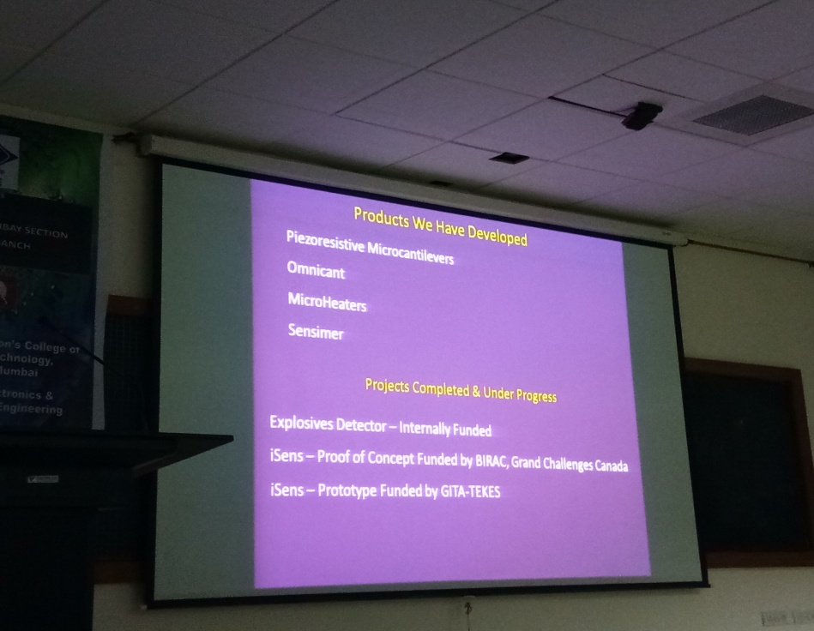

Figure: List of Achievements and Projects Developed

At the end of the lecture, few students asked questions regarding the topic and were very satisfied with the answer from Dr Nitin Kale . He concluded his talk by insisting the students and faculty to plan for more of vertical Research & Projects

We thank The Management, The Principal, The HOD, Guest speaker, Participants and supporting faculty’s for their support.

Attendance – 60 Students , 10 Faculty members.

MGMCET NAVI MUMBAI

STB-37121

MUKESH VERMA NEDA KHAN Dr Indra Vijay Singh

BRANCH CHAIRPERSON BRANCH COUNSELOR Head of Department, EXTC

OJAS BALSOTRA

BRANCH VICE-CHAIRPERSON